Air Quality Monitoring System
Air pollution is a major issue in many cities and the air quality index is getting worse every day. According to the World Health Organization report, more people are killed prematurely by the effects of hazardous particles presented in the air than from car accidents. According to the Environmental Protection Agency (EPA), indoor air can be 2 to 5 times more toxic than outdoor air. So here we build a device to monitor air quality by measuring PM2.5 and PM10 particles in the air.

Nova PM Sensor SDS011
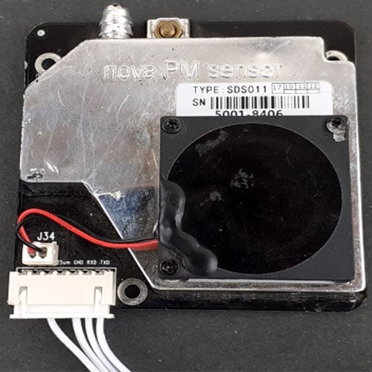

he SDS011 Sensor is a very recent Air Quality Sensor developed by Nova Fitness. It works on the principle of laser scattering and can get the particle concentration between 0.3 to 10μm in the air. This sensor consists of a small fan, air inlet valve, Laser diode, and photodiode. The air enters through the air inlet where a light source (Laser) illuminates the particles and the scattered light is transformed into a signal by a photodetector. These signals are then amplified and processed to get the particle concentration of PM2.5 and PM10.
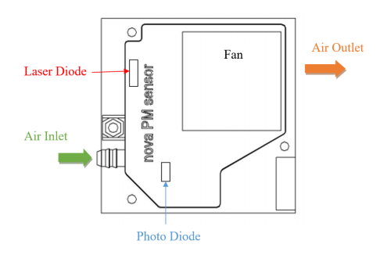

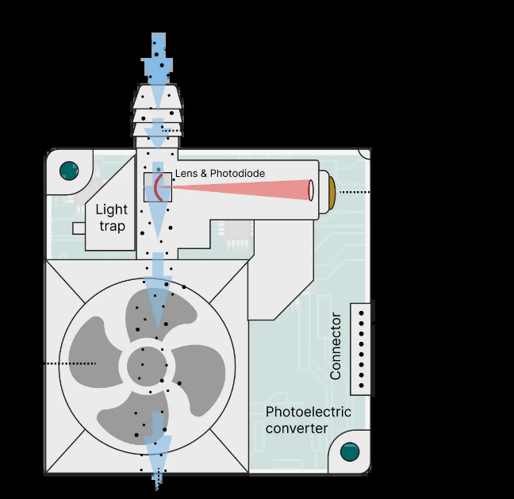

SDS011 Sensor Specifications:
- Output: PM2.5, PM10
- Measuring Range: 0.0-999.9μg/m3
- Input Voltage: 4.7V to 5.3V
- Maximum Current: 100mA
- Sleep Current:2mA
- Response Time: 1 second
- Serial Data Output Frequency: 1 time/second
- Particle Diameter Resolution: ≤ 0.3μm
- Relative Error:10%
- Temperature Range: -20~50°C

0.96’ OLED Display Module
OLED (Organic Light-Emitting Diodes) is a self light-emitting technology, constructed by placing a series of organic thin films between two conductors. A bright light is produced when an electric current is applied to these films. OLEDs are using the same technology as televisions, but have fewer pixels than in most of our TVs.
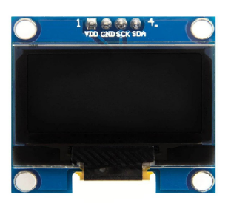

Pin Name | Other Names | Description
Gnd | Ground | Ground pin of the module
Vdd | Vcc, 5V | Power pin (3-5V tolerable)
SCK | D0,SCL,CLK | Acts as the clock pin. Used for both I2C and SPI
SDA | D1,MOSI | Data pin of the module. Used for both IIC and SPI

Program
#include <SDS011.h>
#include <OakOLED.h>
#include<DHT.h>

DHT dht(D5,DHT11);

OakOLED oled;

float p10, p25;
int error;

SDS011 my_sds;

void setup() {

Serial.begin(9600);
dht.begin();
// SDS011 connected to D3 and D4
my_sds.begin(D3,D4);

oled.begin();
oled.clearDisplay();

oled.setTextSize(1);
oled.setTextColor(1); // WHITE text
oled.setCursor(0,0);
}

void loop() {
int temp=dht.readTemperature();
int hum=dht.readHumidity();

error = my_sds.read(&p25, &p10);

if (!error) {

oled.clearDisplay();
oled.setCursor(0,0);

oled.print("PM2.5: ");
oled.println(p25);

oled.print("PM10: ");
oled.println(p10);

oled.print("Temp: ");
oled.println(temp);

oled.print("Hum: ");
oled.print(hum);

oled.display();

Serial.print("PM2.5: ");
Serial.println(p25);

Serial.print("PM10: ");
Serial.println(p10);

Serial.println("--------------------");
}

delay(1000);
}

